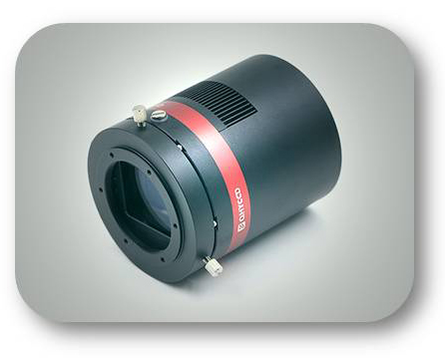
QHYCCD
New Product Announcement
October 19, 2017
QHY128C and QHY367C
35mm Format Cameras

QHYCCD is proud to announce the release of two exciting new 35mm format color cameras. The QHY128C uses a 24 Megapixel sensor with 5.96u pixels and the QHY367C uses a 36 Megapixel sensor with 4.88u pixels. Both models incorporate the latest technology and offer:
- USB 3.0, 5 FPS up to 30 FPS for partial frames
- Ultra High Performance
- Ultra Low Read Noise and Dark Current
- High Dynamic Range
- Zero Amplifier Glow
- Unique Thermal Noise Reduction Technology
- 128MB DDRII Image Buffer
- True RAW Image Output
- Anti-Dew Technology
- AR+AR Coated Optical Window
- Anti-reflection Black Case for F2 Imaging Systems
- High Precision Axis Calibration (no need for tilt corrections)

The Sony Exmore IMX128 sensor has been used in a number of commercial products including the Nikon D600, 610 and 750 cameras, and the Sony DSC-RX1 camera. The IMX367 was designed to produce ultra high resolution 4K video as well as 36MP still images. In the QHY cameras, these sensors are implemented specifically for astronomical use with custom thermal noise reduction technology that does not affect the accuracy of the raw image. Amplifier glow can also be an issue with some CMOS cameras, but these new QHY models boast the rare capability of zero amplifier glow, no matter how long the exposure. The image output is a true raw image, without any internal processing for maximum flexibility with image processing software. Other features include a 128MB image buffer that helps tremendously with slower computers using USB 2.0, and when running multiple cameras using the same computer. The optical window has built-in dew control and the chamber is protected from internal humidity condensation. The optical window is AR+AR coated, reducing halos around bright stars. IR blocking is not used so that the cameras can be used with maximum sensitivity to H-alpha and near IR light when desired, or a simple IR blocking filter can be attached for typical RGB imaging with IR cut. Each camera is carefully calibrated to high precision assuring flatness of the sensor to +/- 20 microns from edge to edge, eliminating the need for external adjustments by the user.

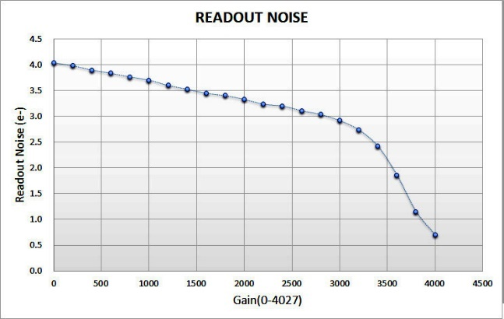
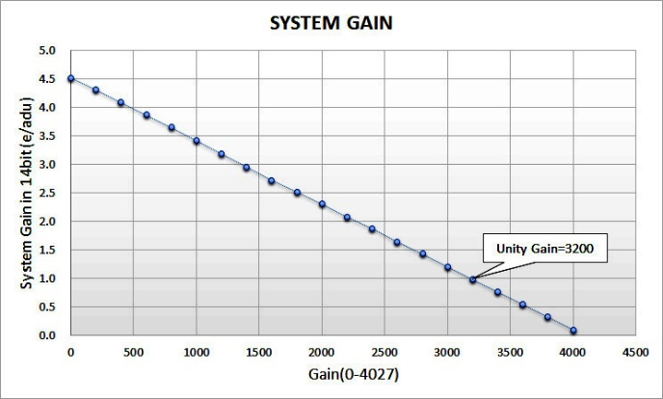

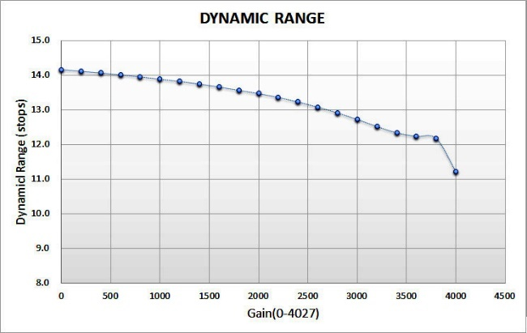
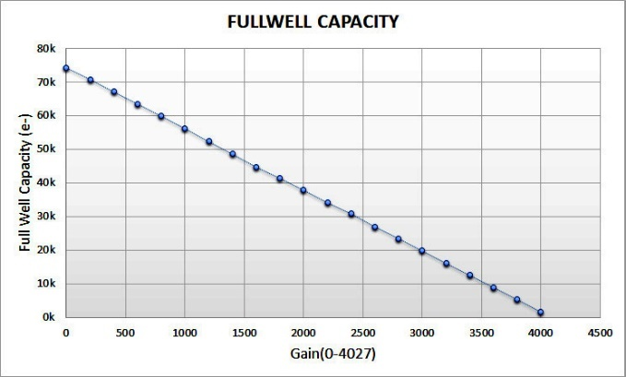

Model | QHY128C | QHY367C
Sensor | Sony IMX128 Color CMOS | Sony IMX367 Color CMOS
Sensor Size | 36mm x 24mm full frame | 36mm x 24mm full frame
Pixel Size | 5.97um x 5.97um | 4.88um x 4.88um
Effective Pixels | 6036 x 4028 24 Megapixels | 7376 x 4938 36.4 Megapixels
Binning | 1 x 1 | 1 x 1
Full Well | 74ke- | 56ke-
Readout Type | Progressive Scan | Progressive Scan
Shutter | Electronic shutter | Electronic shutter
Exposure Time | 60us - 3600 sec | 60us - 3600 sec
Peak QE | 53% | TBD
AD Convert | 14BIT | 14BIT
Readout Noise | 4e-@Low gain, 2.7e-@unity gain 1.8e@high gain | 3.2e-@Low gain, 2.4e@unity gain 1.8e@high gain
Maximum Dynamic Range | More than 1:17000 >14 STOPs | More than 1:17000 >14 STOPs
Mechanical Interface | M54/0.75 female thread | M54/0.75 female thread
TEC | 2-stage TEC -35C below ambient | 2-stage TEC -35C below ambient
Weight(Camera only) | 788g | 788g
Power Consumption | 30W @ 100% TEC, 13W @ 50%TEC | 30W @ 100% TEC, 13W @ 50%TEC
Interface | USB3.0, 12V DC Power socket withock(2.1mm) | USB3.0, 12V DC Power socket wlock(2.1mm)
Frame Rate | 5FPS@Full Resolution  9FPS@2160 LINES (e.g. 7400*2160, 4096*2160)  16.5FPS@1080 LINES (e.g. 7400*1080,1920*1080)  22.5FPS@768 LINES  32FPS@480 LINES | 3.2FPS@Full Frame  7FPS@2160 LINES (e.g. 7400*2160, 4096*2160)  14FPS@1080 LINES (e.g. 7400*1080,1920*1080)  19FPS@768 LINES, 30FPS@480 LINES  40FPS@320 LINES, 83FPS@100 LINES
Graphs represent typical performance of QHY128C camera

For more information please contact QHYCCD or visit http://qhyccd.com/QHY128.html

